**Online Job Portal**

Prathamesh Tari 001886537

**Summary:**

This is an online job portal website implemented using Spring MVC and hibernate to allow users to post jobs as well apply for the posted jobs. The users can view all jobs posted on the website but you cannot apply to a job unless you are logged in. New users can register themselves to apply for the job. There is an option for registration on the log in screen for new users to create an account. Mail api is implemented which gives notification to the user when he applies for a new job. An employer can also post job on the website but he too needs to register himself to be able to post. An employer also registers with the company he is affiliated and he can post jobs for that company only. Employers are able to view all jobs posted by other employers too from the same company. He can also update jobs for the company that he belongs to. Authorization and authentication has been implemented along with validation and sanitation. The website is safe and secured from sql injection and it does not allow unauthorized access to other pages.

**Functionality**:

Implemented interceptor and validator along with filters for sanitization. Also implemented mail api to give notification to the user when a new job application is done.

**Roles:**

**Employer –** Can register itself, can login and post job, update and delete jobs from the website

**Employee –** Can register itself, can login and apply for the jobs posted on the website

**Technologies:**

Spring MVC

Hibernate

Javax Mail API

HandlerInterceptorAdapter

Validator

Filter

**Home Page**



**Login page**

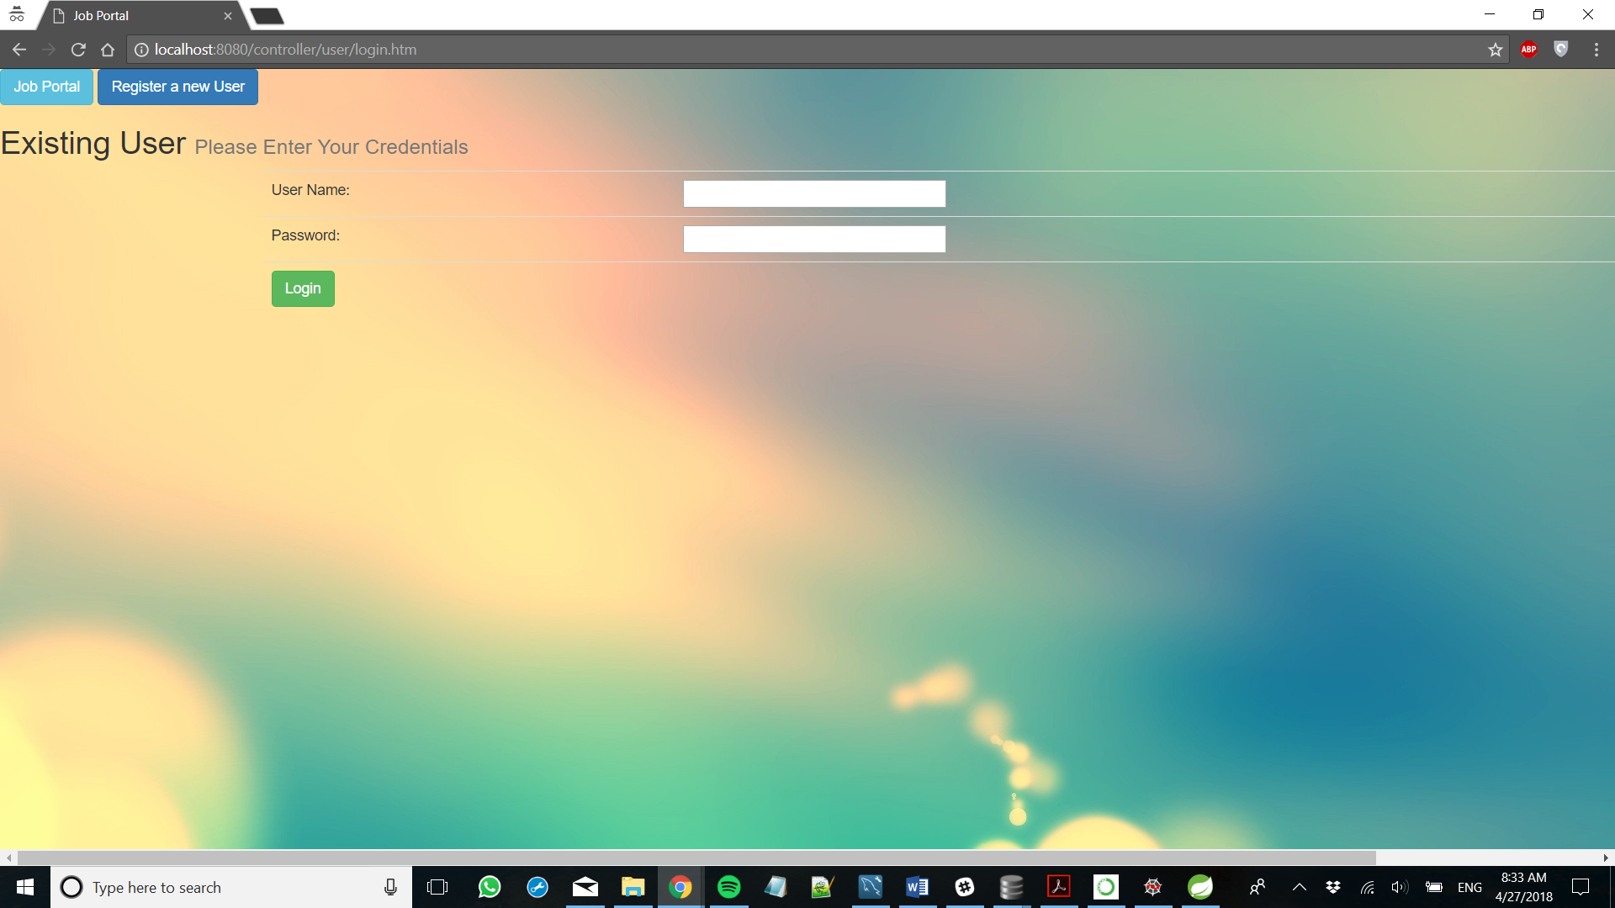

**Employer Login**

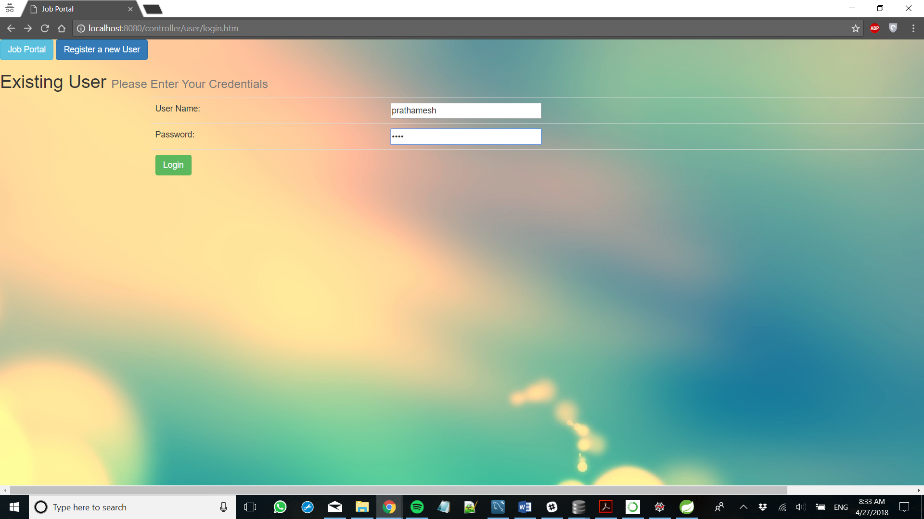

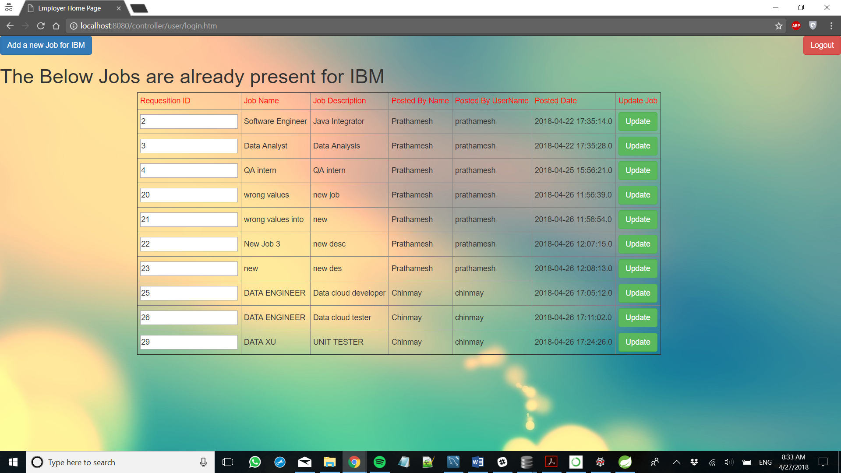

**Jobs posted by employer’s company**

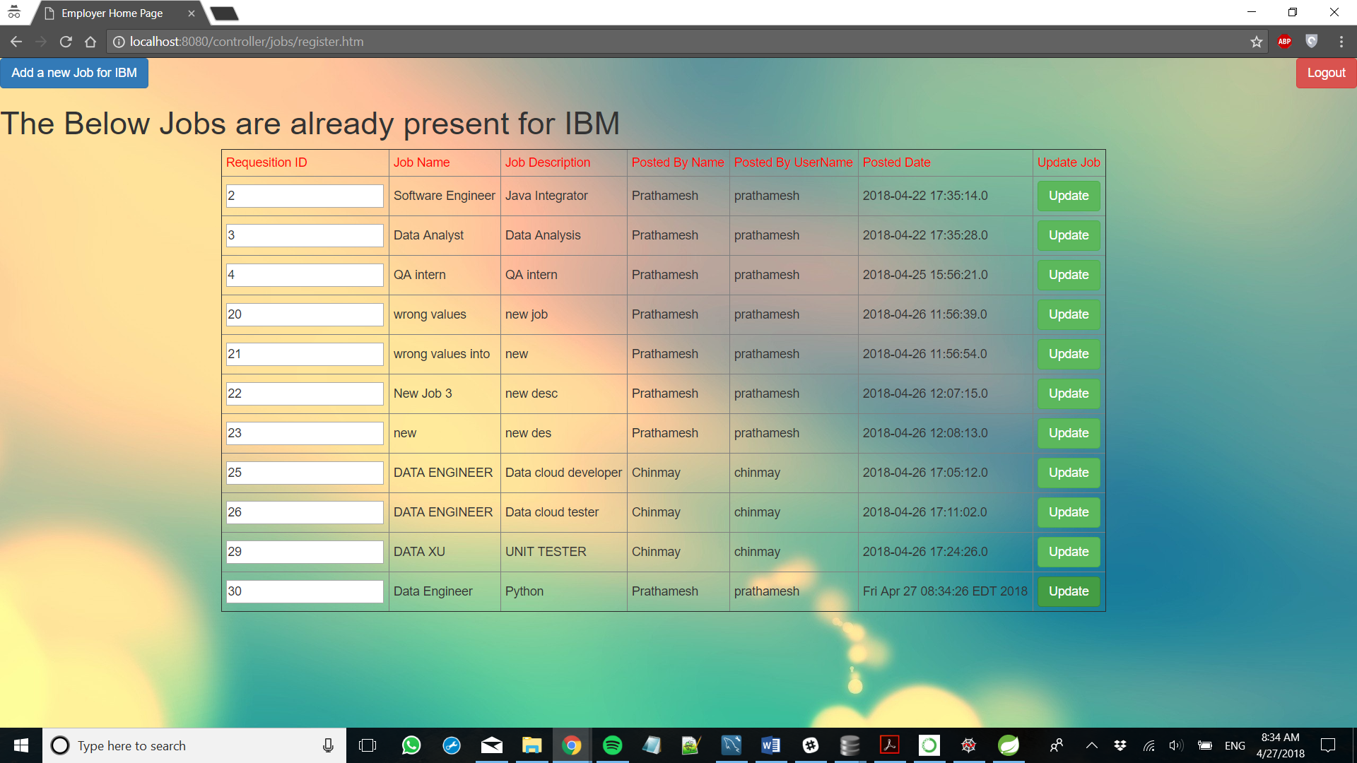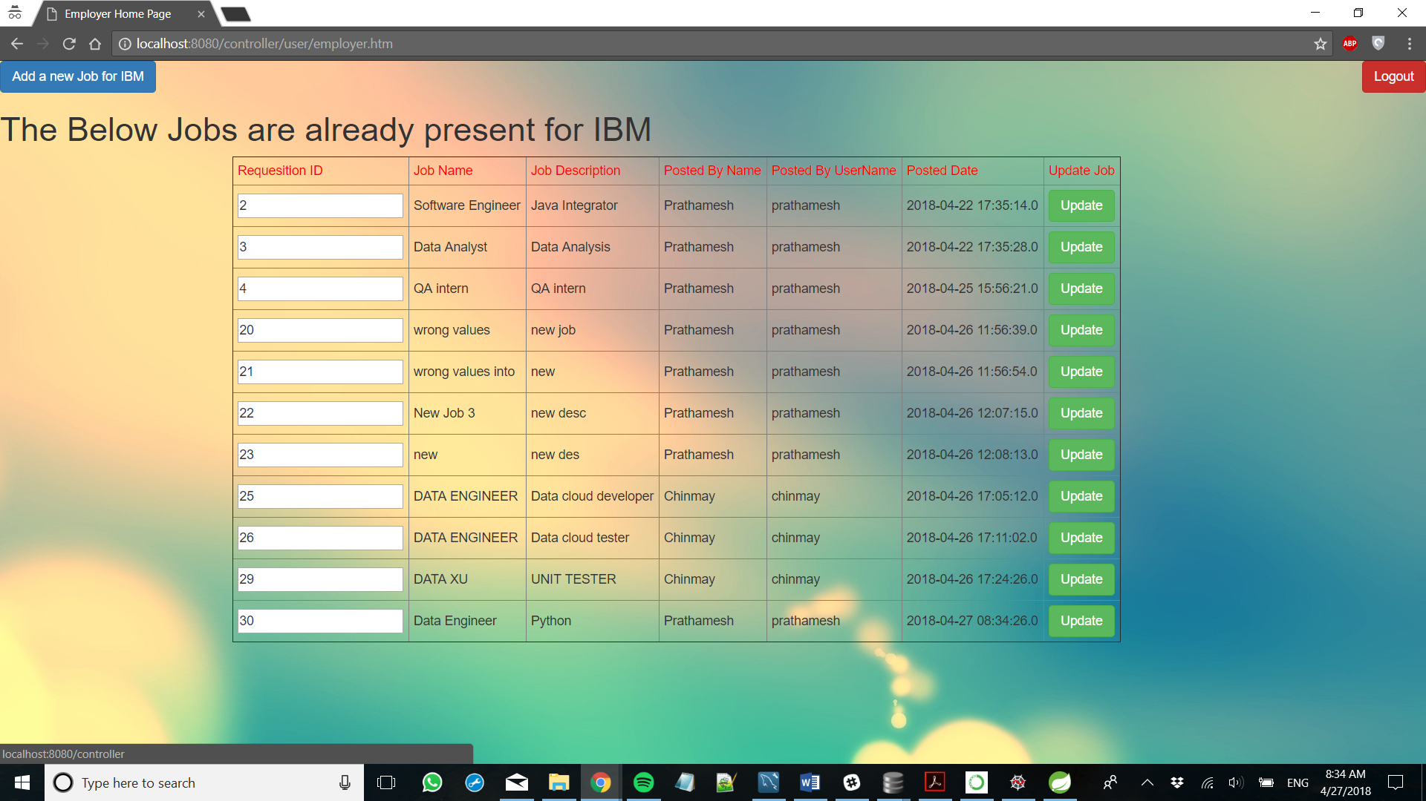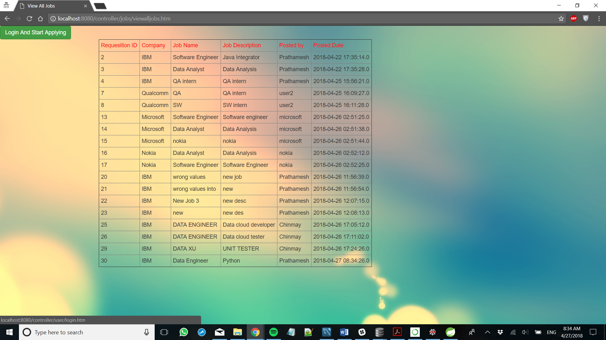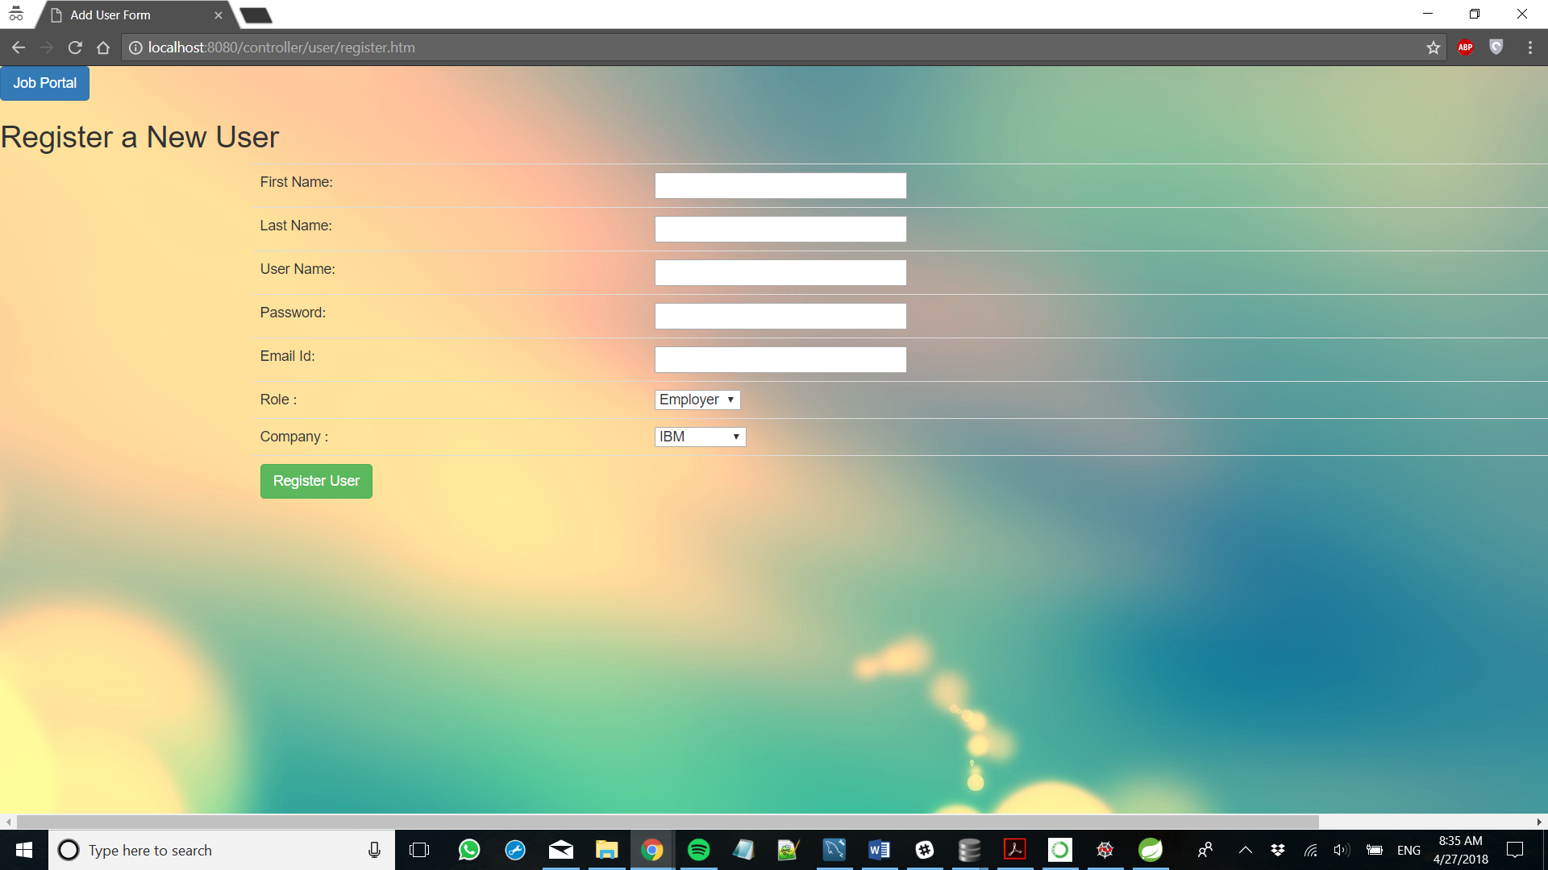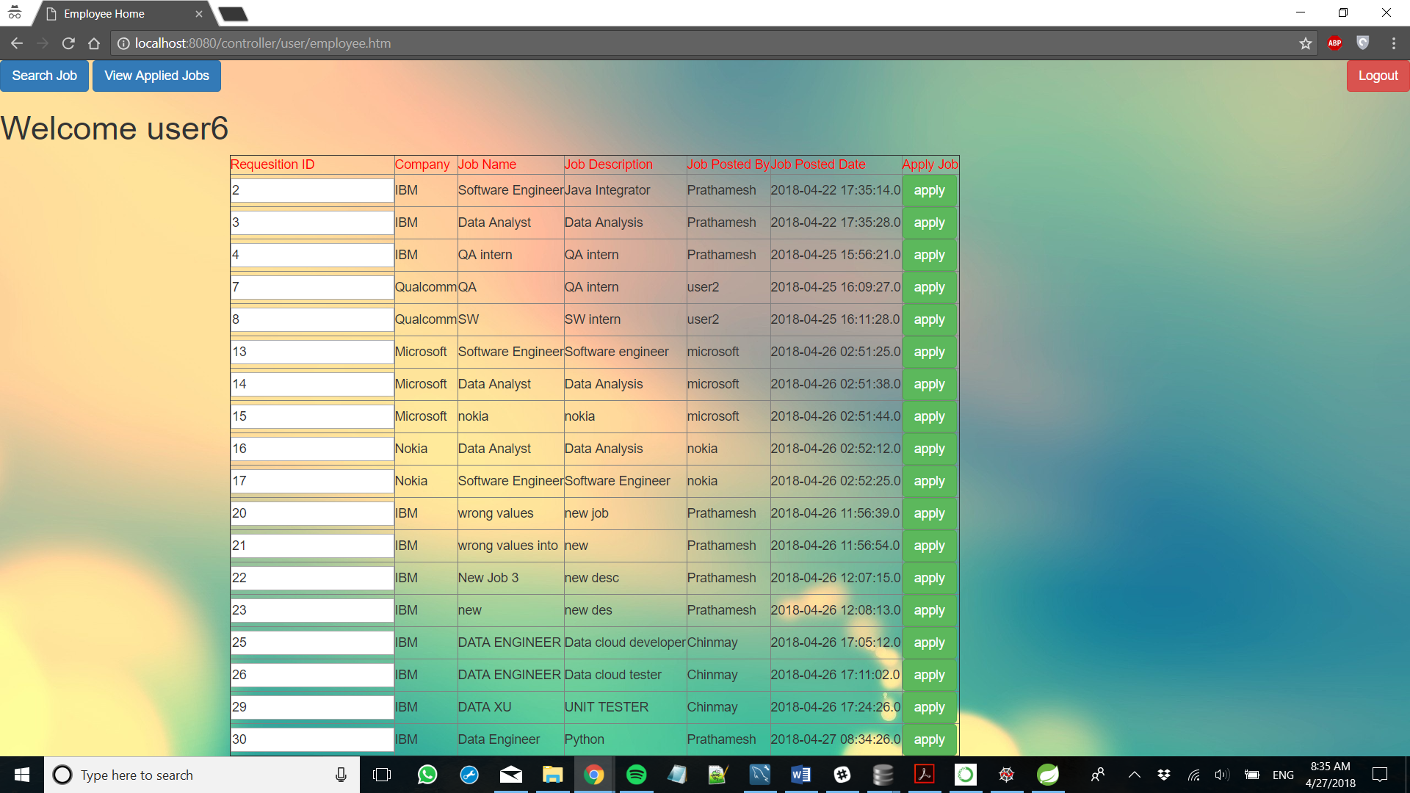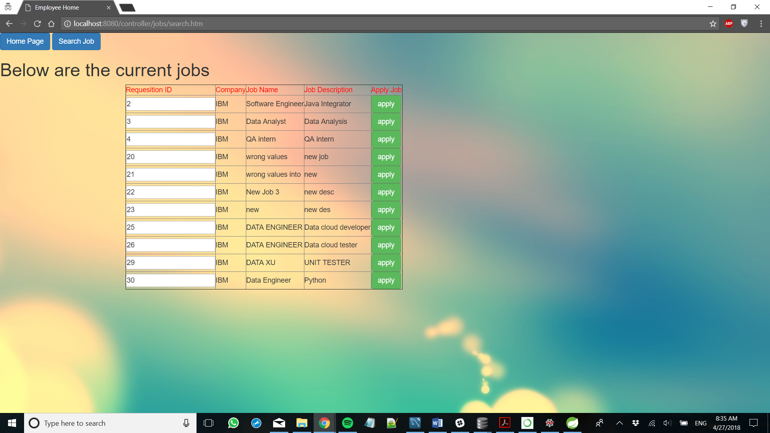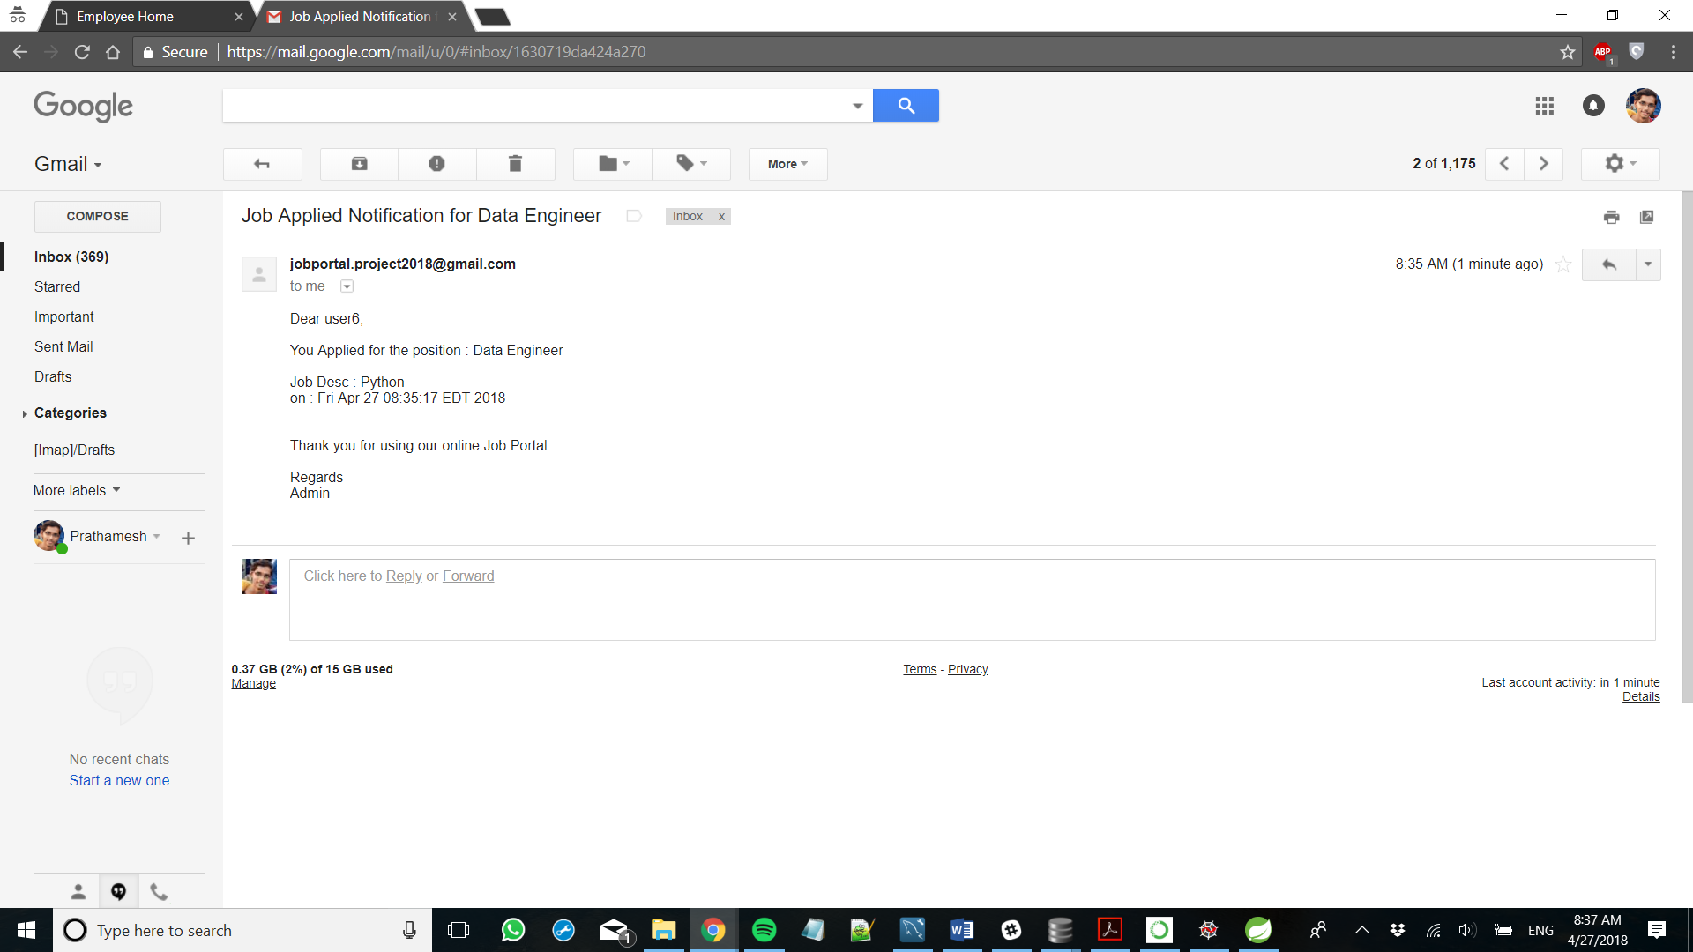

**Appendix**

**package** com.me.JobPortal.controller;

**import** javax.servlet.http.HttpServletRequest;

**import** javax.servlet.http.HttpSession;

**import** org.springframework.stereotype.Controller;

**import** org.springframework.web.bind.annotation.RequestMapping;

**import** org.springframework.web.bind.annotation.RequestMethod;

**import** org.springframework.web.servlet.ModelAndView;

**import** com.me.JobPortal.pojo.JobsList;

**import** com.me.JobPortal.pojo.Users;

@Controller

@RequestMapping("/authorize/*")

**public** **class** AuthorizationController {

@RequestMapping(value = "/authorize/error.htm", method = RequestMethod.***GET***)

**protected** ModelAndView addjobs(HttpServletRequest request) **throws** Exception {

ModelAndView mv = **new** ModelAndView();

mv.setViewName("errorpage");

**return** mv;

}

@RequestMapping(value = "/authorize/JobUpdateError.htm", method = RequestMethod.***GET***)

**protected** ModelAndView errorjobs(HttpServletRequest request) **throws** Exception {

ModelAndView mv = **new** ModelAndView();

mv.setViewName("errorpage-jobupdate");

**return** mv;

}

}

**package** com.me.JobPortal.controller;

**import** java.util.List;

**import** javax.servlet.http.HttpServletRequest;

**import** javax.servlet.http.HttpSession;

**import** org.springframework.beans.factory.annotation.Autowired;

**import** org.springframework.beans.factory.annotation.Qualifier;

**import** org.springframework.stereotype.Controller;

**import** org.springframework.validation.BindingResult;

**import** org.springframework.web.bind.WebDataBinder;

**import** org.springframework.web.bind.annotation.InitBinder;

**import** org.springframework.web.bind.annotation.ModelAttribute;

**import** org.springframework.web.bind.annotation.RequestMapping;

**import** org.springframework.web.bind.annotation.RequestMethod;

**import** org.springframework.web.servlet.ModelAndView;

**import** com.me.JobPortal.DAO.CompaniesDAO;

**import** com.me.JobPortal.DAO.JobsDAO;

**import** com.me.JobPortal.DAO.UsersDAO;

**import** com.me.JobPortal.exception.CompaniesException;

**import** com.me.JobPortal.pojo.Companies;

**import** com.me.JobPortal.pojo.JobsList;

**import** com.me.JobPortal.pojo.Users;

**import** com.me.JobPortal.validator.CompaniesValidator;

@Controller

@RequestMapping("/company/*")

**public** **class** CompaniesController {

@Autowired

@Qualifier("companyDao")

CompaniesDAO companyDao;

@Autowired

@Qualifier("companyValidator")

CompaniesValidator validator;

@Autowired

@Qualifier("jobsDao")

JobsDAO jobsDao;

@Autowired

@Qualifier("userDao")

UsersDAO userDao;

@InitBinder

**private** **void** initBinder(WebDataBinder binder) {

binder.setValidator(validator);

}

@RequestMapping(value = "/company/register.htm", method = RequestMethod.***POST***)

**protected** ModelAndView registerNewUser(HttpServletRequest request, @ModelAttribute("company") Companies companies, BindingResult result) **throws** Exception {

validator.validate(companies, result);

**if** (result.hasErrors()) {

**return** **new** ModelAndView("register-company", "company", companies);

}

**try** {

System.***out***.print("registerNewCompany");

Companies c = companyDao.register(companies);

**return** **new** ModelAndView("company-add", "company", c);

} **catch** (CompaniesException e) {

System.***out***.println("Exception: " + e.getMessage());

**return** **new** ModelAndView("error", "errorMessage", "error while registering company");

}

}

@RequestMapping(value = "/company/register.htm", method = RequestMethod.***GET***)

**protected** ModelAndView registerUser() **throws** Exception {

System.***out***.print("registerUser");

**return** **new** ModelAndView("register-company", "company", **new** Companies());

}

@RequestMapping(value = "/company/delete.htm", method = RequestMethod.***POST***)

**protected** ModelAndView searchjobs(HttpServletRequest request) **throws** Exception {

ModelAndView mv = **new** ModelAndView();

HttpSession session = (HttpSession) request.getSession();

Users u = (Users) session.getAttribute("user");

**int** compId = Integer.*parseInt*(request.getParameter("compID"));

Companies comp = companyDao.getById(compId);

companyDao.delete(comp);

mv.addObject("companies", companyDao.list());

mv.setViewName("admin-home");

**return** mv;

}

}

package com.me.JobPortal.controller;

import java.util.Date;

import java.util.List;

import javax.servlet.http.HttpServletRequest;

import javax.servlet.http.HttpSession;

import org.hibernate.HibernateException;

import org.springframework.beans.factory.annotation.Autowired;

import org.springframework.beans.factory.annotation.Qualifier;

import org.springframework.http.HttpRequest;

import org.springframework.mail.SimpleMailMessage;

import org.springframework.mail.javamail.JavaMailSender;

import org.springframework.stereotype.Controller;

import org.springframework.validation.BindingResult;

import org.springframework.web.bind.WebDataBinder;

import org.springframework.web.bind.annotation.InitBinder;

import org.springframework.web.bind.annotation.ModelAttribute;

import org.springframework.web.bind.annotation.RequestMapping;

import org.springframework.web.bind.annotation.RequestMethod;

import org.springframework.web.servlet.ModelAndView;

import com.me.JobPortal.DAO.CompaniesDAO;

import com.me.JobPortal.DAO.JobsDAO;

import com.me.JobPortal.DAO.UsersDAO;

import com.me.JobPortal.exception.JobsException;

import com.me.JobPortal.pojo.Companies;

import com.me.JobPortal.pojo.JobsList;

import com.me.JobPortal.pojo.Users;

import com.me.JobPortal.validator.JobsValidator;

@Controller

@RequestMapping("/jobs/*")

public class JobsController {

@Autowired

@Qualifier("jobsDao")

JobsDAO jobsDao;

@Autowired

@Qualifier("userDao")

UsersDAO userDao;

@Autowired

@Qualifier("companyDao")

CompaniesDAO companyDao;

@Autowired

@Qualifier("jobsValidator")

JobsValidator validator;

@Autowired

private JavaMailSender mailSender;

@InitBinder

private void initBinder(WebDataBinder binder) {

binder.setValidator(validator);

}

@RequestMapping(value = "/jobs/register.htm", method = RequestMethod.GET)

protected ModelAndView addjobs(HttpServletRequest request) throws Exception {

ModelAndView mv = new ModelAndView();

HttpSession session = (HttpSession) request.getSession();

Users u = (Users) session.getAttribute("user");

mv.addObject("companyName", u.getCompany().getCompanyName());

mv.addObject("joblist", new JobsList());

mv.setViewName("job-add");

return mv;

}

@RequestMapping(value = "/jobs/register.htm", method = RequestMethod.POST)

protected ModelAndView registerNewUser(HttpServletRequest request, @ModelAttribute("joblist") JobsList joblist,

BindingResult result) throws Exception {

validator.validate(joblist, result);

if (result.hasErrors()) {

return new ModelAndView("job-add", "joblist", joblist);

}

try {

ModelAndView mv = new ModelAndView();

HttpSession session = (HttpSession) request.getSession();

Users u = (Users) session.getAttribute("user");

System.out.print("Add New Job");

joblist.setCompany(u.getCompany());

joblist.setPostedName(u.getFirstName());

joblist.setPostedID(u.getUsername());

JobsList job = jobsDao.register(joblist);

mv.addObject("jobs", jobsDao.listCompany(u.getCompany()));

mv.addObject("joblist", job);

mv.setViewName("employer-home");

return mv;

} catch (JobsException e) {

System.out.println("Exception: " + e.getMessage());

return new ModelAndView("error", "errorMessage", "error while adding job");

}

}

@RequestMapping(value = "/jobs/update.htm", method = RequestMethod.GET)

protected ModelAndView updatejobs(HttpServletRequest request) throws Exception {

ModelAndView mv = new ModelAndView();

HttpSession session = (HttpSession) request.getSession();

int id = Integer.parseInt(request.getParameter("jobId"));

JobsList job = jobsDao.getJob(id);

System.out.println("THE PRODUCT ID IS :" + id);

Users u = (Users) session.getAttribute("user");

mv.addObject("companyName", u.getCompany().getCompanyName());

// mv.addObject("joblist", new JobsList());

mv.addObject("jobList", job);

mv.setViewName("job-update");

return mv;

}

@RequestMapping(value = "/jobs/update.htm", method = RequestMethod.POST)

protected ModelAndView updatejob(HttpServletRequest request) throws Exception {

ModelAndView mv = new ModelAndView();

HttpSession session = (HttpSession) request.getSession();

int id = Integer.parseInt(request.getParameter("jobId"));

JobsList job = jobsDao.getJob(id);

job.setJobName(request.getParameter("jobName"));

job.setJobDesc(request.getParameter("jobDesc"));

System.out.println("THE PRODUCT ID IS :" + id);

jobsDao.update(job);

Users u = (Users) session.getAttribute("user");

mv.addObject("jobList", job);

mv.setViewName("update-success");

return mv;

}

@RequestMapping(value = "/jobs/modify.htm", method = RequestMethod.POST)

protected ModelAndView modifyJob(HttpServletRequest request, @ModelAttribute("joblist") JobsList joblist,

BindingResult result) throws Exception {

try {

ModelAndView mv = new ModelAndView();

String action = request.getParameter("action");

int job_id = Integer.parseInt(request.getParameter("productID"));

System.out.println("the action is : " + action);

if (action.equals("Delete")) {

JobsList job = jobsDao.getJob(job_id);

jobsDao.deleteJob(job);

mv.setViewName("employer-home");

}

return mv;

} catch (JobsException e) {

System.out.println("Exception: " + e.getMessage());

return new ModelAndView("error", "errorMessage", "error while adding job");

}

}

@RequestMapping(value = "/jobs/add.htm", method = RequestMethod.POST)

protected ModelAndView addJob(HttpServletRequest request) throws Exception {

try {

boolean flag = false;

ModelAndView mv = new ModelAndView();

HttpSession session = (HttpSession) request.getSession();

Users u = (Users) session.getAttribute("user");

int job_id = Integer.parseInt(request.getParameter("jobID"));

for (JobsList job1 : u.getJoblists()) {

if (job1.getJobID() == job_id) {

flag = true;

}

}

System.out.print("Add New Job");

if (!flag) {

JobsList job = jobsDao.getJob(job_id);

userDao.update(u, job);

System.out.println("Entered the job addition new para");

job.getUsers().add(u);

jobsDao.update(job);

String address = u.getEmail().getEmailAddress();

String subject = "Job Applied Notification for " +job.getJobName();

String message = "Dear "+u.getFirstName()+","+"\n"+"\nYou Applied for the position : "+job.getJobName()+"\n"+"\nJob Desc : " +job.getJobDesc()

+"\non : " +new Date() +"\n"+"\n"+"\nThank you for using our online Job Portal"+"\n"+"\nRegards"+"\nAdmin";

SimpleMailMessage email = new SimpleMailMessage();

email.setTo(address);

email.setSubject(subject);

email.setText(message);

mailSender.send(email);

mv.addObject("jobs", jobsDao.listCompany(u.getCompany()));

mv.addObject("joblist", job);

mv.setViewName("add-success");

flag = false;

return mv;

} else {

System.out.println("Entered the other para where its already added");

mv.addObject("jobs", null);

mv.setViewName("add-already");

return mv;

}

} catch (JobsException e) {

System.out.println("Exception: " + e.getMessage());

return new ModelAndView("error", "errorMessage", "error while adding job");

}

}

@RequestMapping(value = "/jobs/search.htm", method = RequestMethod.GET)

protected ModelAndView searchjob(HttpServletRequest request) throws Exception {

ModelAndView mv = new ModelAndView();

HttpSession session = (HttpSession) request.getSession();

Users u = (Users) session.getAttribute("user");

mv.setViewName("search-job");

return mv;

}

@RequestMapping(value = "/jobs/search.htm", method = RequestMethod.POST)

protected ModelAndView searchjobs(HttpServletRequest request) throws Exception {

ModelAndView mv = new ModelAndView();

HttpSession session = (HttpSession) request.getSession();

Users u = (Users) session.getAttribute("user");

String name = request.getParameter("inputtext");

String search = request.getParameter("searchkey");

if (search.equalsIgnoreCase("jobname")) {

List<JobsList> jobs = jobsDao.listJobname(name);

mv.addObject("jobs", jobs);

if (jobs.isEmpty())

System.out.println("The returned list is empty");

for (JobsList job : jobs) {

System.out.println("The matching jobs are : " + job.getJobName());

}

} else if (search.equalsIgnoreCase("company")) {

Companies c = companyDao.get(name);

if (c == null) {

mv.setViewName("search-fail");

return mv;

}

List<JobsList> jobs = jobsDao.listCompany(c);

if (jobs.isEmpty()) {

mv.setViewName("search-failjobs");

return mv;

}

mv.addObject("jobs", jobs);

}

mv.setViewName("search-success");

return mv;

}

@RequestMapping(value = "/jobs/applied.htm", method = RequestMethod.GET)

protected ModelAndView appliedjob(HttpServletRequest request) throws Exception {

ModelAndView mv = new ModelAndView();

mv.setViewName("jobs-applied");

return mv;

}

@RequestMapping(value = "/jobs/viewalljobs.htm", method = RequestMethod.GET)

protected ModelAndView viewAllJob(HttpServletRequest request) throws Exception {

ModelAndView mv = new ModelAndView();

mv.addObject("jobs", jobsDao.list());

mv.setViewName("viewalljobs");

return mv;

}

}

package com.me.JobPortal.controller;

import java.util.Set;

import javax.servlet.http.HttpServletRequest;

import javax.servlet.http.HttpSession;

import org.springframework.beans.factory.annotation.Autowired;

import org.springframework.beans.factory.annotation.Qualifier;

import org.springframework.stereotype.Controller;

import org.springframework.validation.BindingResult;

import org.springframework.web.bind.WebDataBinder;

import org.springframework.web.bind.annotation.InitBinder;

import org.springframework.web.bind.annotation.ModelAttribute;

import org.springframework.web.bind.annotation.RequestMapping;

import org.springframework.web.bind.annotation.RequestMethod;

import org.springframework.web.servlet.ModelAndView;

import com.me.JobPortal.DAO.CompaniesDAO;

import com.me.JobPortal.DAO.JobsDAO;

import com.me.JobPortal.DAO.UsersDAO;

import com.me.JobPortal.exception.UserException;

import com.me.JobPortal.pojo.Companies;

import com.me.JobPortal.pojo.JobsList;

import com.me.JobPortal.pojo.Users;

import com.me.JobPortal.validator.UserValidator;

@Controller

@RequestMapping("/user/*")

public class UsersController {

@Autowired

@Qualifier("usersDao")

UsersDAO usersDao;

@Autowired

@Qualifier("usersValidator")

UsersValidator validator;

@Autowired

@Qualifier("companiesDao")

CompaniesDAO companiesDao;

@Autowired

@Qualifier("jobsDao")

JobsDAO jobsDao;

@InitBinder

private void initBinder(WebDataBinder binder) {

binder.setValidator(validator);

}

@RequestMapping(value = "/user/login.htm", method = RequestMethod.GET)

protected String goToUserHome(HttpServletRequest request) throws Exception {

return "home";

}

@RequestMapping(value = "/user/login.htm", method = RequestMethod.POST)

protected ModelAndView loginUser(HttpServletRequest request) throws Exception {

ModelAndView mv = new ModelAndView();

HttpSession session = (HttpSession) request.getSession();

try {

System.out.print("loginUser");

Users u = userDao.get(request.getParameter("username"), request.getParameter("password"));

if(u == null){

System.out.println("UserName/Password does not exist");

session.setAttribute("errorMessage", "UserName/Password does not exist");

mv.setViewName("error");

return mv;

}

session.setAttribute("user", u);

String role = u.getRole().trim();

if (role.equals("employee")){

System.out.println("Entered here");

mv.addObject("jobs", jobsDao.list());

mv.setViewName("employee-home");

return mv ;

}

else if (role.equals("employer")){

mv.setViewName("employer-home");

return mv;

}

else if(role.equals("admin")){

mv.addObject("companies", companyDao.list());

mv.setViewName("admin-home");

return mv;

}

else

return null;

} catch (UserException e) {

System.out.println("Exception: " + e.getMessage());

session.setAttribute("errorMessage", "error while login");

mv.setViewName("error");

return mv;

}

}

@RequestMapping(value = "/user/register.htm", method = RequestMethod.GET)

protected ModelAndView registerUser() throws Exception {

System.out.print("registerUser");

ModelAndView mv = new ModelAndView();

mv.addObject("companies", companyDao.list());

mv.addObject("user",new Users());

mv.setViewName("register-user");

return mv;

}

@RequestMapping(value = "/user/employee.htm", method = RequestMethod.GET)

protected ModelAndView employeeHome() throws Exception {

System.out.print("Employee Home");

ModelAndView mv = new ModelAndView();

mv.addObject("jobs", jobsDao.list());

mv.setViewName("employee-home");

return mv;

}

@RequestMapping(value = "/user/employer.htm", method = RequestMethod.GET)

protected ModelAndView employerHome(HttpServletRequest request) throws Exception {

System.out.print("Employeer Home");

HttpSession session = (HttpSession) request.getSession();

Users u = (Users) session.getAttribute("user");

ModelAndView mv = new ModelAndView();

mv.addObject("jobs", jobsDao.listCompany(u.getCompany()));

mv.setViewName("employer-home");

return mv;

}

@RequestMapping(value = "/user/admin.htm", method = RequestMethod.GET)

protected ModelAndView adminHome() throws Exception {

System.out.print("Admin Home");

ModelAndView mv = new ModelAndView();

mv.addObject("companies", companyDao.list());

mv.setViewName("admin-home");

return mv;

}

@RequestMapping(value = "/user/register.htm", method = RequestMethod.POST)

protected ModelAndView registerNewUser(HttpServletRequest request, @ModelAttribute("user") Users users, BindingResult result) throws Exception {

validator.validate(users, result);

if (result.hasErrors()) {

ModelAndView mv = new ModelAndView();

mv.addObject("companies", companyDao.list());

mv.addObject("user", users);

mv.setViewName("register-user");

return mv;

}

try {

System.out.print("registerNewUser");

String role = request.getParameter("myRole");

users.setRole(role);

String company = request.getParameter("myCompany");

System.out.println("The Companies is :" +company);

Companies c = companyDao.get(company);

System.out.println("The company ID : " +c.getCompanyId());

users.setCompany(c);

Users u = userDao.register(users);

request.getSession().setAttribute("user", u);

return new ModelAndView("user-home", "user", u);

} catch (UserException e) {

System.out.println("Exception: " + e.getMessage());

return new ModelAndView("error", "errorMessage", "error while login");

}

}

}

package com.me.JobPortal.pojo;

import javax.persistence.Column;

import javax.persistence.Entity;

import javax.persistence.GeneratedValue;

import javax.persistence.GenerationType;

import javax.persistence.Id;

import javax.persistence.Table;

@Entity

@Table(name = "companiestable")

public class Companies {

@Id

@GeneratedValue(strategy=GenerationType.AUTO)

@Column(name="companiesid")

private int companiesId;

@Column(name="companiesname")

private String companiesName;

@Column(name="companiesaddress")

private String companiesAddress;

@Column(name="companiesdesc")

private String companiesDescription;

public Companies(){

}

public Companies( String companiesName, String companiesAddress, String companiesDescription){

this.companiesName = companiesName;

this.companiesAddress = companiesAddress;

this.companiesDescription = companiesDescription;

}

public int getCompaniesId() {

return companiesId;

}

public void setCompaniesId(int companiesId) {

this.companiesId = companiesId;

}

public String getCompaniesName() {

return companiesName;

}

public void setCompaniesName(String companiesName) {

this.companiesName = companiesName;

}

public String getCompaniesAddress() {

return companiesAddress;

}

public void setCompaniesAddress(String companiesAddress) {

this.companiesAddress = companiesAddress;

}

public String getCompanyDescription() {

return companiesDescription;

}

public void setCompaniesDescription(String companiesDescription) {

this.companiesDescription = companiesDescription;

}

}

package com.me.JobPortal.pojo;

import javax.persistence.Column;

import javax.persistence.Entity;

import javax.persistence.GeneratedValue;

import javax.persistence.GenerationType;

import javax.persistence.Id;

import javax.persistence.OneToOne;

import javax.persistence.PrimaryKeyJoinColumn;

import javax.persistence.Table;

import org.hibernate.annotations.Parameter;

import org.hibernate.annotations.GenericGenerator;

@Entity

@Table(name = "email_table")

public class EmailAddress {

@Id

@GeneratedValue(strategy = GenerationType.AUTO)

@Column(name = "emailID", unique = true)

private long id;

@Column(name = "email_address")

private String emailAddress;

@OneToOne

@PrimaryKeyJoinColumn

private Users users;

public EmailAddress() {

}

public EmailAddress(String emailAddress) {

this.emailAddress = emailAddress;

}

public long getId() {

return id;

}

public void setId(long id) {

this.id = id;

}

public String getEmailAddress() {

return emailAddress;

}

public void setEmailAddress(String emailAddress) {

this.emailAddress = emailAddress;

}

public Users getUser() {

return users;

}

public void setUser(Users users) {

this.users = users;

}

}

package com.me.JobPortal.pojo;

import javax.persistence.CascadeType;

import javax.persistence.Column;

import javax.persistence.Entity;

import javax.persistence.GeneratedValue;

import javax.persistence.GenerationType;

import javax.persistence.Id;

import javax.persistence.ManyToOne;

import javax.persistence.OneToOne;

import javax.persistence.PrimaryKeyJoinColumn;

import javax.persistence.Table;

@Entity

@Table(name = "Employer_Table")

@PrimaryKeyJoinColumn(name = "employeeID")

public class Employers extends Users {

private Companies companies;

public Employers(){

}

public Companies getCompany() {

return companies;

}

public void setCompany(Companies companies) {

this.companies = companies;

}

}

package com.me.JobPortal.pojo;

import java.util.Set;

import java.util.Date;

import javax.persistence.CascadeType;

import javax.persistence.Column;

import javax.persistence.Entity;

import javax.persistence.GeneratedValue;

import javax.persistence.GenerationType;

import javax.persistence.Id;

import javax.persistence.ManyToMany;

import javax.persistence.ManyToOne;

import javax.persistence.PrimaryKeyJoinColumn;

import javax.persistence.Table;

import javax.persistence.Transient;

@Entity

@Table(name = "Jobs")

public class JobsList {

@Id

@GeneratedValue(strategy=GenerationType.AUTO)

@Column(name = "jobsID", unique=true, nullable = false)

private int jobsID;

@Column(name = "jobsname")

private String jobsName;

@Column(name = "jobsDesc")

private String jobsDesc;

@Column(name = "uname")

private String postedName;

@Column(name = "uId")

private String postedID;

@Column(name = "posteddate")

private Date postedDate;

@ManyToOne

@PrimaryKeyJoinColumn

private Companies companies;

@ManyToMany(mappedBy="jobslists")

private Set<Users> users;

public JobsList(){

}

public JobsList(String jobsname, String jobsdesc){

this.jobsName = jobsname;

this.jobsDesc = jobsdesc;

this.postedDate = new Date();

}

public int getJobID() {

return jobsID;

}

public void setJobsID(int jobsID) {

this.jobsID = jobsID;

}

public Set<Users> getUsers() {

return users;

}

public void setUsers(Set<Users> users) {

this.users = users;

}

public String getJobsName() {

return jobsName;

}

public void setJobsName(String jobsName) {

this.jobsName = jobsName;

}

public String getJobsDesc() {

return jobsDesc;

}

public void setJobsDesc(String jobsDesc) {

this.jobsDesc = jobsDesc;

}

public Companies getCompanies() {

return companies;

}

public void setCompanies(Companies companies) {

this.companies = companies;

}

public String getPostedName() {

return postedName;

}

public void setPostedName(String postedName) {

this.postedName = postedName;

}

public String getPostedID() {

return postedID;

}

public void setPostedID(String postedID) {

this.postedID = postedID;

}

public Date getPostedDate() {

return postedDate;

}

public void setPostedDate(Date postedDate) {

this.postedDate = postedDate;

}

}

package com.me.JobPortal.pojo;

import javax.persistence.Column;

import javax.persistence.Entity;

import javax.persistence.GeneratedValue;

import javax.persistence.GenerationType;

import javax.persistence.Id;

import javax.persistence.Inheritance;

import javax.persistence.InheritanceType;

import javax.persistence.Table;

@Entity

@Table(name="persons_table")

@Inheritance(strategy=InheritanceType.JOINED) //table per subclass

public class Persons {

@Id

@GeneratedValue(strategy=GenerationType.IDENTITY)

@Column(name = "personsID", unique=true, nullable = false)

private long personsID;

@Column(name = "firstName")

private String firstName;

@Column(name ="lastName")

private String lastName;

public Persons(){

}

public long getPersonsID() {

return personsID;

}

public void setPersonsID(long personsID) {

this.personsID = personsID;

}

public String getFirstName() {

return firstName;

}

public void setFirstName(String firstName) {

this.firstName = firstName;

}

public String getLastName() {

return lastName;

}

public void setLastName(String lastName) {

this.lastName = lastName;

}

}

package com.me.JobPortal.pojo;

import java.util.HashSet;

import java.util.Set;

import javax.persistence.CascadeType;

import javax.persistence.Column;

import javax.persistence.Entity;

import javax.persistence.FetchType;

import javax.persistence.Inheritance;

import javax.persistence.InheritanceType;

import javax.persistence.JoinTable;

import javax.persistence.ManyToMany;

import javax.persistence.ManyToOne;

import javax.persistence.OneToMany;

import javax.persistence.OneToOne;

import javax.persistence.PrimaryKeyJoinColumn;

import javax.persistence.Table;

import javax.persistence.JoinColumn;

import org.springframework.beans.factory.annotation.Autowired;

@Entity

@Table(name = "users_table")

@PrimaryKeyJoinColumn(name = "personsID")

public class Users extends Persons {

@Column(name = "userName")

private String username;

@Column(name = "password")

private String password;

@OneToOne(cascade = CascadeType.ALL)

private EmailAddress emailAddress;

@Column(name = "roles")

private String roles;

@ManyToOne

private Companies companies;

@ManyToMany

@JoinTable (

name="users_job_table",

joinColumns = {@JoinColumn(name="personsID", nullable = false, updatable = false)},

inverseJoinColumns = {@JoinColumn(name="jobsID" )}

)

private Set<JobsList> jobslists = new HashSet<JobsList>();

public Users(String username, String password, String roles) {

this.username = username;

this.password = password;

this.roles = roles;

}

public Users() {

}

public String getUsername() {

return username;

}

public void setUsername(String username) {

this.username = username;

}

public String getPassword() {

return password;

}

public void setPassword(String password) {

this.password = password;

}

public EmailAddress getEmail() {

return emailAddress;

}

public void setEmail(EmailAddress emailAddress) {

this.emailAddress = emailAddress;

}

public String getRole() {

return roles;

}

public void setRole(String role) {

this.roles = role;

}

public Companies getCompany() {

return companies;

}

public void setCompany(Companies companies) {

this.companies = companies;

}

public Set<JobsList> getJobslists() {

return jobslists;

}

public void setJoblists(Set<JobsList> jobslists) {

this.jobslists = jobslists;

}

}